TMT/Shakeel Enterprises/S0331/2025 19.06.2025

To
Shakeel Taarkash
Shakeel Enterprises, SURVEY NO 241 SHOP NO 1,, Yadgir - 585202, KA
Click to call: +91-9972557540
E-mail: shakeeltaarkash@gmail.com

Dear sir,

Sub: - SUPPLY OF TWO STATIONED HYDRAULIC BAGASSE BAILING PRESS MACHINE.

Thank you very much for your enquiry regarding your requirement of bagasse bailing press with two stage. We are glad to inform you that we would be in a position to supply you the required equipment. Given below are the required specifications and description of the machine and our terms and conditions.

PRICES
The cost of bagasse bailing press machine along with two stationed having capacity 8 to 10 MT/hour. Along with 40 HP Crompton Motor high speed high discharge hydraulic power pack, along with control panel for manual and auto operations is Rs 12,20,000/-
(Rupees Twelve Lakhs Twenty Thousand Only)

LIST OT EQUIPMENT

- CORMPTON MOTOR 40 HP/AC 1 NUMBER.
- HYDRAULIC CYLINDERS 1 NOS.
- POWER PACK WITH HEAT EXCHANGER
- COMPLETE PIPING FROM HYDRAULIC UNIT TO PRESS
- ELECTRICAL PANEL WITH PROXIMITIES AND THERMO CONTORLLER.

TERMS AND CONDITIONS
- The above price are ex-our works, Hyderabad.

- Taxes as applicable at the time of delivery.

- DELIVERY: 5 Weeks from the date of your technical and commercially clear order along with advance.

- PAYMENT: 50% value of the order as advance, and balance after inspection and prior to delivery.

- GUARANTEE: should any part(S) prove defective in terms of design and workmanship, we agree to replace those parts that are manufactured by us or our subcontractors free of cost with in one year from the date of dispatch.

- COMMISSIONING & ERECTION: we will supervise the erection and commissioning our equipment. The required manpower at your site will have to be provided by you.

- VALADITY: Our offer is valid for your acceptance for 30 days more.

- EXCLUSIONS: All civil engineering works at your site such as foundation work, foundation bolts, piping form your heat exchanger to our equipment, electrical connections to the equipment from your supply point provided by you.

GENERAL TERMS & CONDITIONS:

- Price quoted per unit ex-work. Hyderabad.
- Following charges are additional to your account.
- Freight Charge : As actual to be borne by you.
- Sales Tax : 18% Extra as applicable
- Packing charge : As actual to be borne by you.
- Insurance : As actual to be borne by you.
- Payment : 50% advance along with order balance before delivery but after inspection at our works.
- Delivery : with in 5 weeks
- Validity : One month from the date of submission.
- Inspection : Inspection at our works prior to dispatch.
- Warranty : The machine is warranted for a period of 12 months from the date of dispatch against any manufacturing defects/ faulty material or bad workmanship of any part or component but not against any kind of abnormal or improper use of machine. Defective part or component will be replaced or repaired free of cost. Electrical components are outside the scope of this warranty.
- Commissioning : Erection & commissioning done by you, but required technical support & guidance provide by us at additional cost.

NOTE:
- Oil is not in scope of our supply.
- Raw material for trial is to be arranged by you at your cost.

We are sure you will find our offer in line with your requirements. Should you require any further clarification please contact 9246221106
Thanking you and assuring you of our best services.

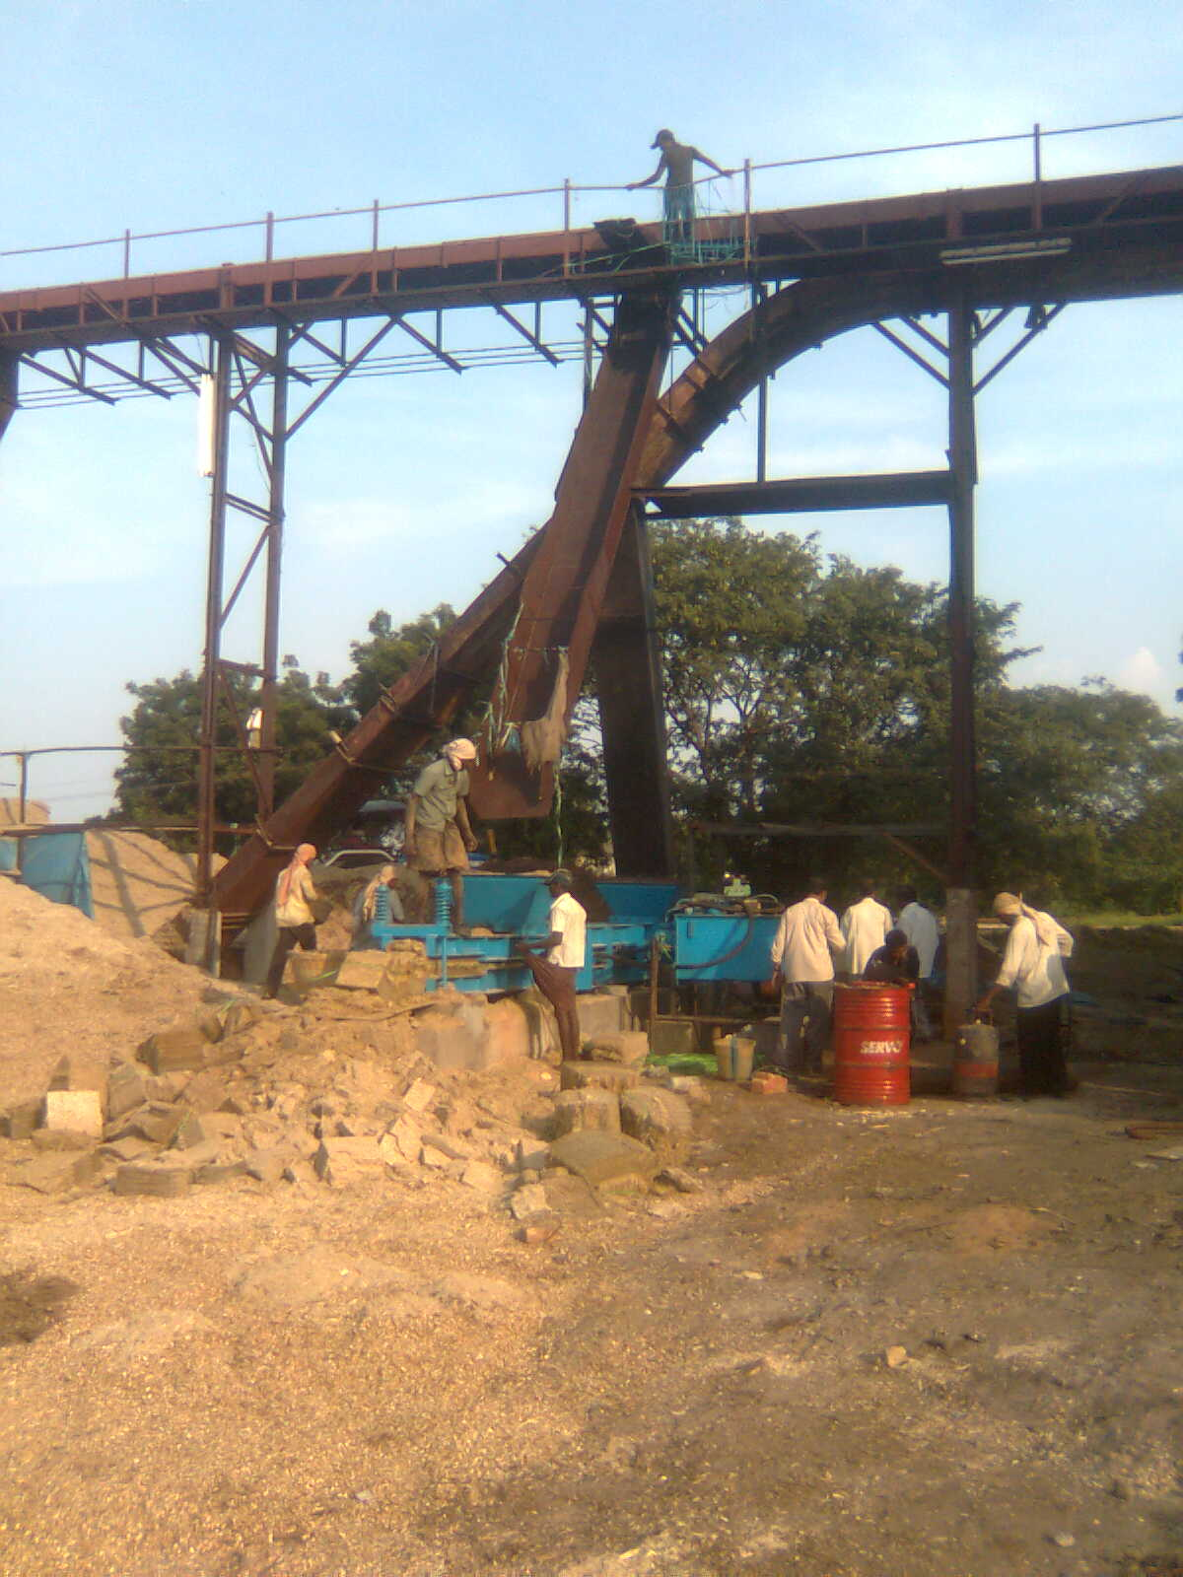

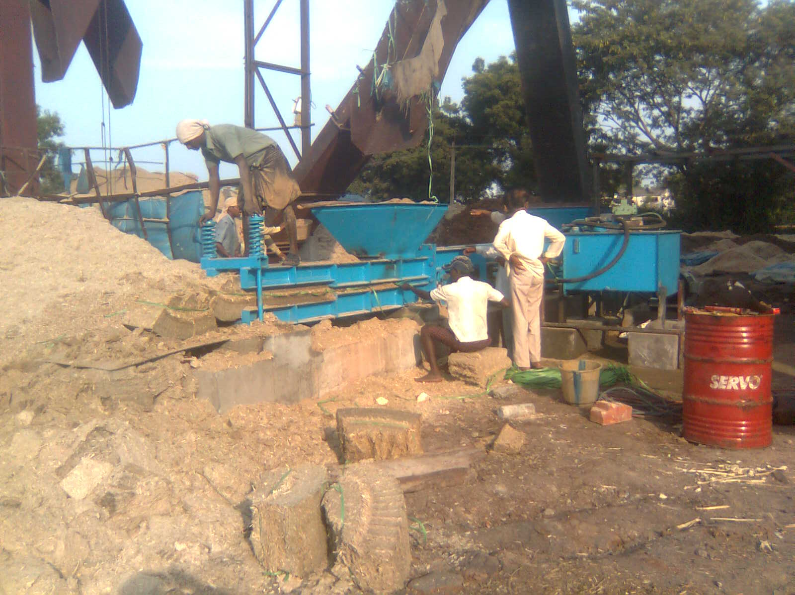

For Techno Machine Tools

( T. Sivaramakrishna)

